Art Lesson Portfolio

Theme: Matter and Energy
Grade Level: Grade 5 Science

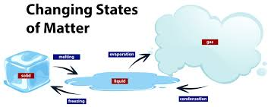 The art brings out Matter and in its various forms. The students can see that Matter can be found in solid, liquid, and gas in three forms. This level of students will easily understand the relationship between and energy. That Matter, when in solid form, has less energy when more energy is added, it melts into the liquid state; a very common example is water. This will help students to understand the process of melting easily. Consequently, adding more energy to matter in liquid form will turn to gas in a process known as evaporation; a common example is steam. The art also indicates that the process can be reversed; that is, by reducing energy in gas, it can be converted to liquid in a process known as condensation. Further reduction of energy in liquid can cause freezing, which is the conversion of liquid to solid. A very common example is the formation of ice from water.

Lesson Plan

Engagement/Connecting to Prior Knowledge | The lessons start by reminding students various tools were used in scientific investigation and reasoning—for example, hand lenses, thermometers, primary balances, magnets timing devices. Then I will ask the learners to explain their experiences. Which tools were easy to use? Which tools were interesting to use? What patterns did you observe? After listening to the learner's response, I will introduce the topic on Matter and Energy. Having used various tools, I will make the learners realize that Matter is what stuff is made, and Matter has energy. The change of energy in Matter also results in a change of state of Matter.
Teaching Point | In this lesson, I want to teach you that there are three states of Matter. We will get examples around us that solid, liquid, and gas. For example, solid we can use books and pens .liquid we can use water and gas we can use a balloon or inflated ball. I will guide the learners to differentiate the three states of Matter.
Teach | The lesson will start with explaining the Matter and energy. I will ask the learners to give examples of objects around them. I will write the examples given by the learners on the board. I will classify the objects into either solid, liquid, and gas. I will ask the learners to give out more examples in each category. Then I will explain the characteristics of Matter. I will show the learners that Matter has weight and occupies space by immersing a pen in a jug full of water, and the pen will displace water. We will measure various objects' weights to prove Matter has weight, and we will use an empty ball and an inflated to prove even gas has weight. Then I will discuss the reason why Matter is found in various states is due to energy.  We will discuss commonly available example ice cubes when they are inside the fridge, and they are in a solid-state when removed from the fridge, the turn to water, which is liquid form. The water, too, when boiled it turns to vapor, which is in gaseous form.  Finally, after an oral explanation, the learners will engage actively in demonstrating Matter and energy.
Active Engagement | One of the students will carefully remove ice cubes from the freezer. The ice cubes will be placed in an open, clear glass container. After some time, the ice cubes will start to melt to form a liquid, which is water. Then I will ensure every student observes that solid changed to liquid. I will heat one of the beaker's waters and ensure every student observes the steam is formed. At a cautious distance, the learners will observe water turning into gas. Then the next activity, the learners will observe the characteristic of Matter. First, the learners will measure the weight of an empty ball and record in their books. Then using a pump, they will inflate the ball and measure the weight. The learners will be able to see an inflated ball is heavier.
Link/Check for understanding | I will ensure my students have understood what was taught by evaluating through various questions :  What are the examples of solid, liquid, and gas found in our environment?  What occupies more space and has weight an empty ballon or an inflated balloon

Sculpture:
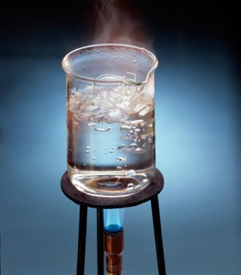 This image clearly shows a demonstration of Matter and its relationship with energy. From the sculpture, one can easily see Matter's solid-state being represented by the glass beaker and the stand, the liquid state represented by water, and the gaseous state due to heating. One can also see the effect of heat on water.
Lesson Plan

Engagement/Connecting to Prior Knowledge | To draw students' attention, I will bring various tools such as a burner, glass beaker, and water. I will have the students observe various changes of Matter due to an increase in energy. I will let the students classify other Matter examples in various forms, for example, soda, car balloon pens, and cloth. I will let the students observe that it changed to steam after heating water in a gaseous state.
Teaching Point | In today's lesson, we are going to observe the change of Matter into various forms practically. I will demonstrate what happens when water is heated.
Teach | Every learner should keenly observe what happens when energy is added into liquid. The learners should observe at a distance. The source of heat, which is filled with gas, serves as a perfect example. I will then add water to the glass beaker. I am using a stand, as shown in the place of the sculpture. Then I will ignite heat from the burner. After 10 minutes, the water will start to boil. After a few minutes of boiling, steam will be formed on the top of the beaker. This demonstrates the change of liquid from liquid to gaseous form.
Active Engagement | In turn, I will give the learners to observe the formation of steam from the boiling water cautiously.
Link/Check for understanding | Today's lesson has explored the effects of heat on liquids. Every student should know that changes in energy in Matter will affect the state of Matter.

Visiting Artist: Lisa Randall

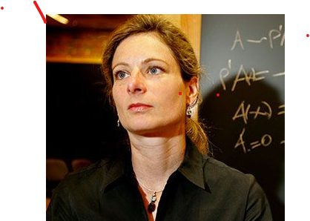The reason why I choose Lisa Randall she describes science in an exciting way. She explores science as a fundamental way of understanding the world. Lisa has proven that to understand the world, we must start from Matter's basics and the energy contained in Matter.
Art center floor plan and center information:
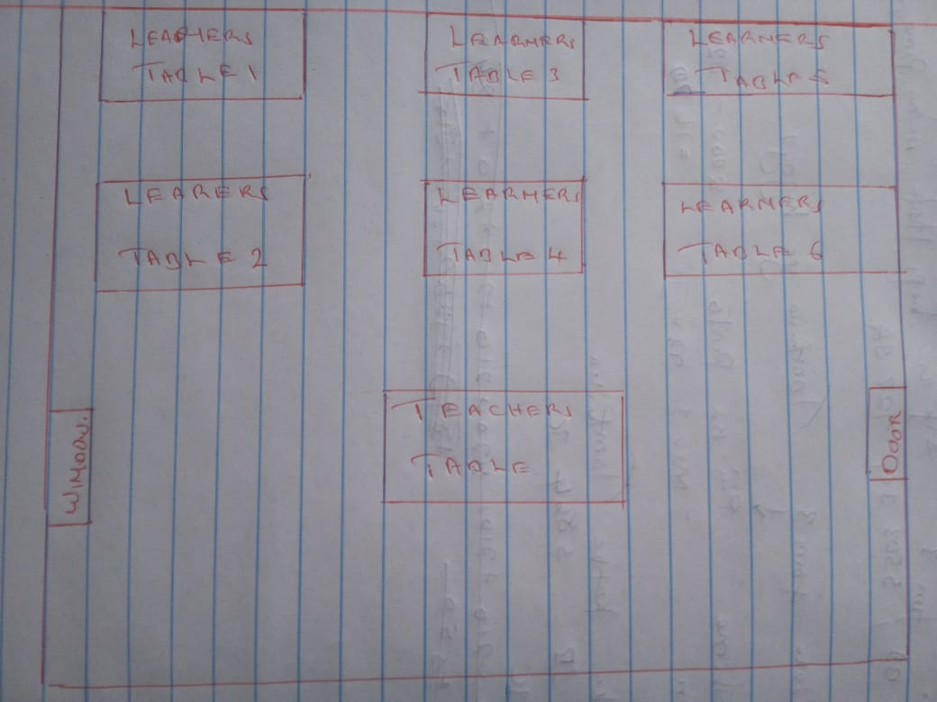

The floor plan indicates the sitting plan of the learners. The art center also has a teacher’s desk where the demonstration is carried out. The teacher's desk is raised to ensure that every student can see the demonstration. The also has a window and a door to ensure its proper aerated and lighted.
Skills I want the students will develop-
During this demonstration, learners should be able to develop the skill of observing. The learner must point out that the steam was formed after heating liquid in the glass beaker. The leaners should also be able to classify various Matter in solid, liquid, and gas. By the end of the lesson, the learners should explain the relationship between Matter and energy.
Basic materials needed for the center-
The following materials are needed in the art center burner, glass beaker, water, books, pens, empty balloon ball, and pump, weighing machine.

Guidelines:
The learners should be orderly seated at their tables.
The learners should strictly adhere to the teacher's rules.
The learners should avoid unnecessary movement during the demonstration.
The learners should handle various tools with caution.
The learners should observe the boiling water.

Assessment instrument
The teacher will assess the learner's ability to differentiate Matter in various states.

Points | 3 | 2 | 1
 | Ability to differentiate solid liquid and gas. | Slight ability to differentiate solid, liquid, and gas | Inability to differentiate solid, liquid, and gas

